

K.R. MANGALAM UNIVERSITY

Name of Student – Aryan Sethi
Roll NO. – 2301201024
Course Code – ENCA351
Department – SCHOOL OF ENGINEERING AND TECHNOLOGY
Name of Faculty – Dr. Aarti
Name of subject- Design and Analysis of Algorithms Lab

Analyzing and Visualizing Recursive

Algorithm Efficiency

Introduction
In computer science, analyzing the efficiency of algorithms is important because it helps us choose the best approach for solving problems. Recursive and iterative solutions often behave differently as input size grows.
The goal of this project is to implement several algorithms, measure their time and space performance, and compare theoretical vs. experimental results.
- Algorithms Implemented
The following algorithms were implemented and analyzed:
  - Fibonacci (Recursive and Dynamic Programming)
  - Merge Sort
  - Quick Sort
  - Insertion Sort
  - Bubble Sort
  - Selection Sort
  - Binary Search

Fibonacci (Recursive)
Theory: Calls itself repeatedly to compute the nth number. Simple but inefficient due to repeated calculations.
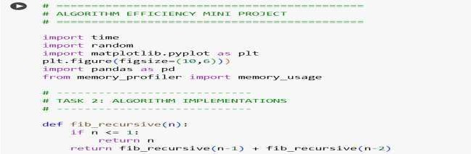
Complexity: Time O(2^n), Space O(n).

Fibonacci (Dynamic Programming)
Theory: Uses iteration and stores results. Much more efficient. Complexity:
Time O(n), Space O(1).
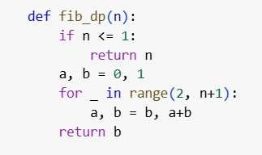
Merge Sort
Theory: Divide and conquer algorithm. Splits, sorts, and merges.
Complexity: Time O(n log n), Space O(n).
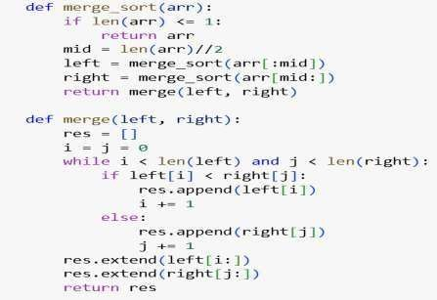
Quick Sort
Theory: Divide and conquer. Partitions around a pivot.
Complexity: Average O(n log n), Worst O(n^2), Space O(log n).

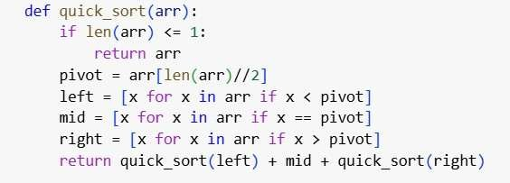
Insertion Sort
Theory: Builds sorted list one element at a time.
Complexity: Best O(n), Worst O(n^2), Space O(1).
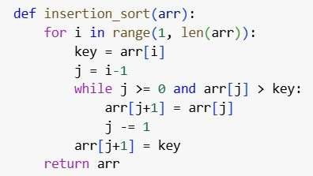
Bubble Sort
Theory: Compares adjacent elements and swaps. Complexity:
Time O(n^2), Space O(1).
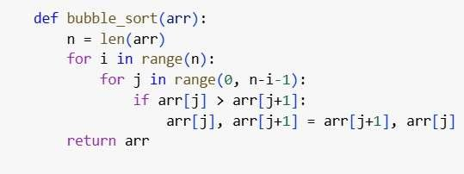
Selection Sort
Theory: Finds minimum and places it at the beginning. Complexity:
Time O(n^2), Space O(1).

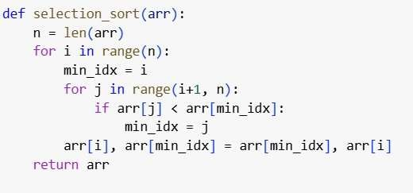
Binary Search
Theory: Efficiently halves the search space in sorted arrays.
Complexity: Time O(log n), Space O(1).
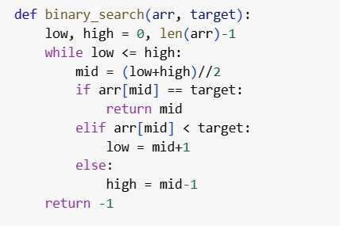

Experimental Profiling & Visualization
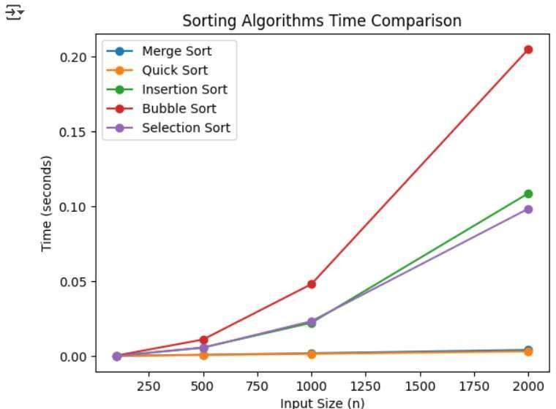

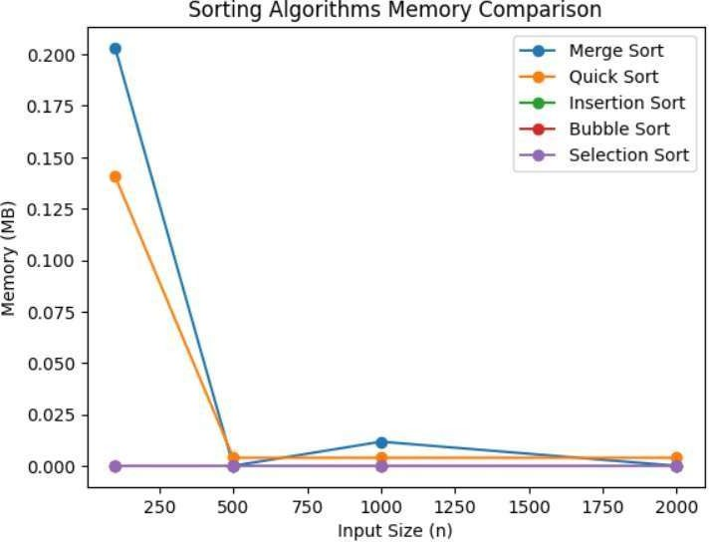
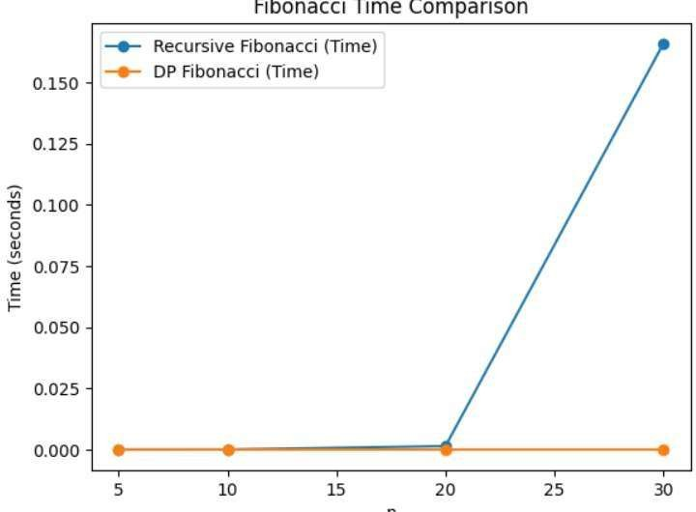

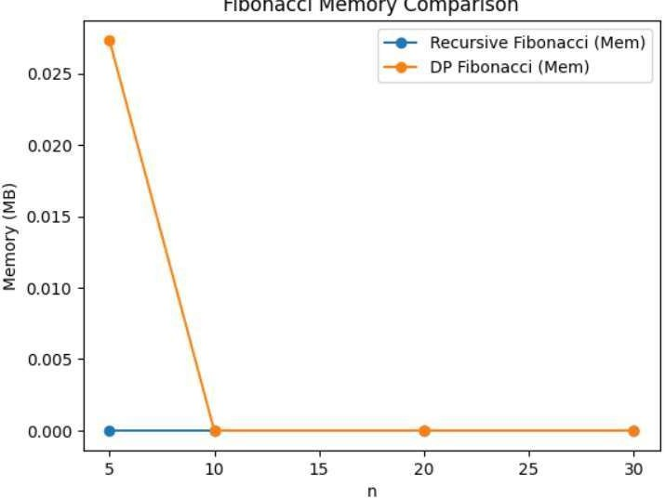
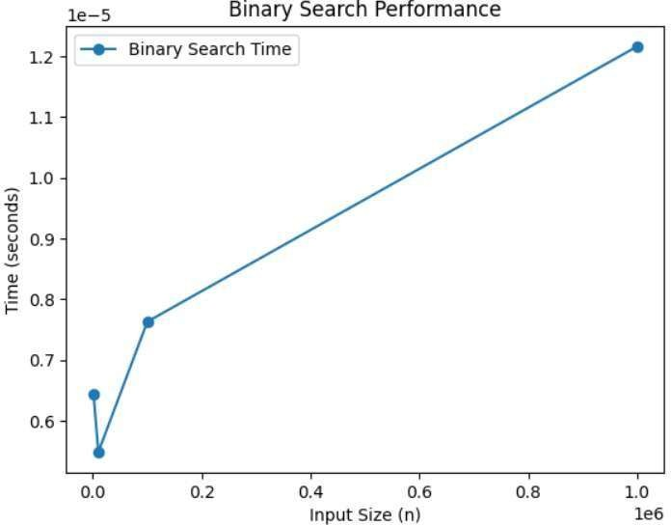

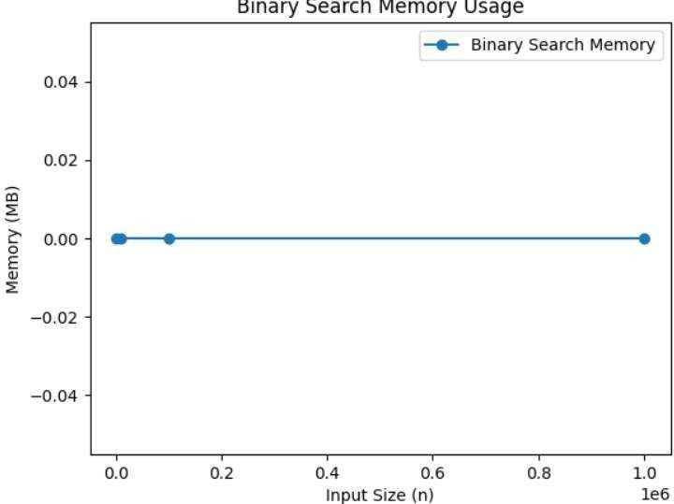
Theoretical Complexity Table
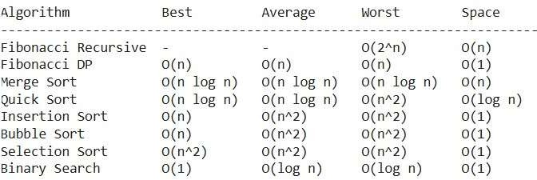

Experimental Results
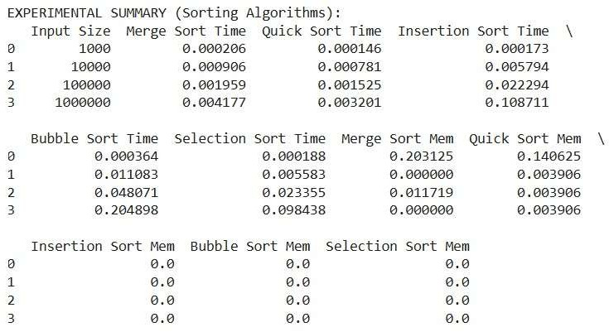
Reflections & Insights
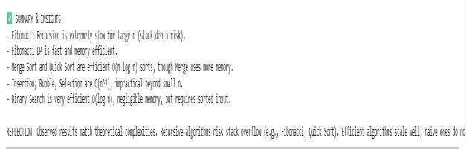

GitHub Repository Link

https://github.com/Aryan2206-jpg

